**Upcoming Events**

**April 18** - Tax Day

**April 22** – Earth Day

**April 26** - Arbor Day Tree Giveaway @ the Pier

**May 13** – Art and Bark in the Park (Lakeside Park)

**May 14** – Mother’s Day

**May 20** – Beach Blvd Cleanup 8-10am, meet at 10th St Parkette

**May 29** – Memorial Day

**June 8** – Annual Neighborhood Cookout

**June 18** – Father’s Day

**CONTRIBUTORS** to this quarter’s newsletter are Christy Stanzcak, Lorna, Kirkham, Mike Martin, Sheila Farland, and Vanisha Patel-Martin.

**VOLUNTEERS** are still needed to fill neighborhood committees, particularly the Social committee, to assist with organizing our annual Neighborhood Cookout, scheduled for June 8th.

**THERE** have been multiple water moccasin sightings at the beach boardwalk and within the neighborhood. Be sure to keep your kids and pets safe!

**WELCOME** to the inaugural edition of Whispering Stories!

We are thrilled to present the quarterly WOHA newsletter, which aims to keep you up to date with the latest news, information, and opportunities in our neighborhood, the best kept secret on Anastasia Island. We welcome your contributions for any future editions, and if you have content you would like to share, please feel free to contact the Whispering Stories staff at whisperingstoriessta@gmail.com. We hope you find the newsletter informative and enjoyable, and we look forward to keeping you informed about all the exciting happenings in our community.

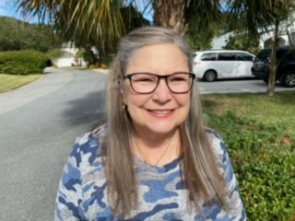**IN LOVING MEMORY** of our beloved friend and neighbor, Martha “Marty” Norberg, who was a loving wife, mother, and cherished friend. The neighborhood will undoubtedly feel the loss of her presence. We are forever grateful for the memories and love that Marty brought into our lives, and we extend our deepest condolences to her family and friends.

In honor of Marty, please consider donating to a special cause that was near and dear to her heart.

https://bestfriends.org/sanctuary

**WITH** the approach of longer days and warmer weather, the foot traffic in our neighborhood is likely to increase. We kindly request that all guests visiting the neighborhood observe the **10-mph speed limit**. We also ask that you are aware of who our gate code is being given out to. Ensuring the **health & safety** of our residents and visitors is our top priority, and we appreciate your cooperation in making our community a safe and enjoyable place for all.

**OUR ISLAND LANDSCAPING PROJECT** is making significant progress. We have successfully trimmed all ten islands, removing dead growth to create space for the upcoming Springtime regeneration. Our gratitude goes out to Lana Bandy, Dale Ratermann,

Jessica Kline, Josh Kline, and Allyson Breger for their hard work in achieving this milestone.

Furthermore, we are pleased to announce that a second team comprising Bob Parker, Sam Iandiorio, and Jim LeClare has been working tirelessly to install irrigation systems across all the islands, with only two remaining to be completed. This significant effort will ensure the optimal health of the new plants that will soon be planted, thereby bringing the project closer to completion.

**A BIG WELCOME** to our new Whispering Oaks Circle neighbors, the DiGiacomos!

Paul, Jackie, daughter Devin, dogs Chewbacca (black Collie mix), Nala (yellow Lab), and cat Moe (white shorthair beauty), have finally made Whispering Oaks home after three years of planning on the lot that they purchased three years ago.

Paul, a structural and forensic engineer originally from Denver CO, did the architectural design of their home, which is carefully constructed to withstand wind surges.

Jackie, a registered nurse originally from Knoxville, TN, shared that they moved here from Orange Park because their family really wanted to live near the beach. They have children and grandchildren in many surrounding areas (soon to be 5 grandchildren!).

Paul and Jackie enjoy the simple things in life. Family, pets, hiking, walking, camping, skiing, and supporting the preservation of nature, and would like to give a heartfelt "thank you" to everyone that has shown them such a warm reception. They are excited to meet the rest of the community.

**THANK YOU** to Steve Johnson and Dale Ratermann for building our beautiful new neighborhood library. We appreciate the time, effort, and dedication that went into bringing this idea to life. It’s located on the island outside of Dale’s house on Whispering Oaks Circle. Please feel free to take a book or leave one behind.

**THE PET REPORT**

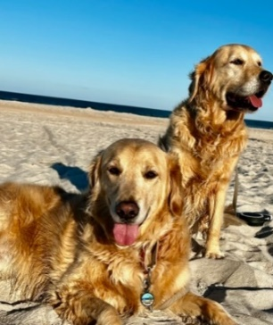George and Roo belong to the Wilson family, which includes Jennifer, John, and Jack. Despite being far away from their birthplace of Istanbul, they have developed a deep affection for their new home in St. Augustine. Going on long walks to the beach is one of their favorite activities, and they can't resist indulging in peanut butter as their go-to treat. If you happen to spot them during their daily walks, don't hesitate to say hello, as they are two of the most cheerful golden retrievers you'll ever meet!

**KIDS CORNER**

An aspiring entrepreneur, Ella Eavenson has created an Etsy page to showcase her creative artwork. Please take a moment to visit her shop, TaupePampaStudios.